Task4

Name: Siyu Liu

Student ID: 8859412

# Screenshots

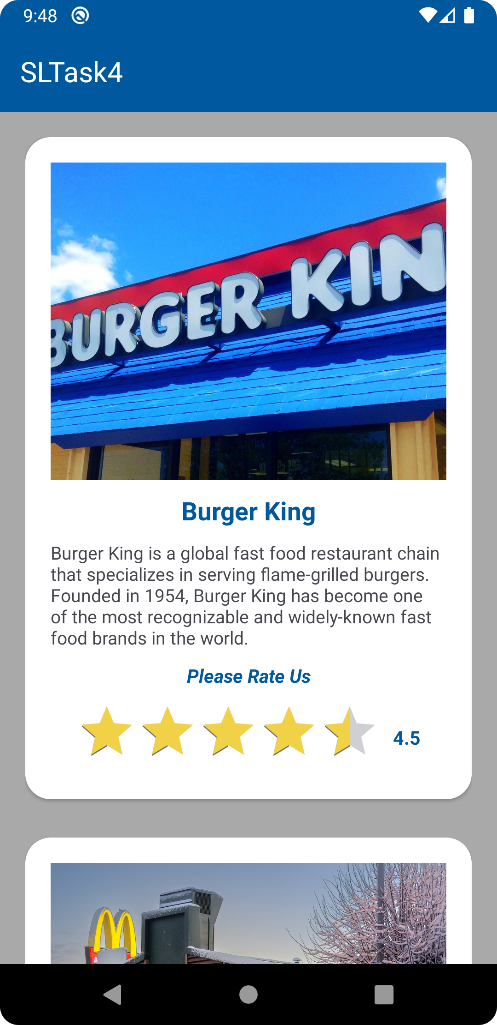 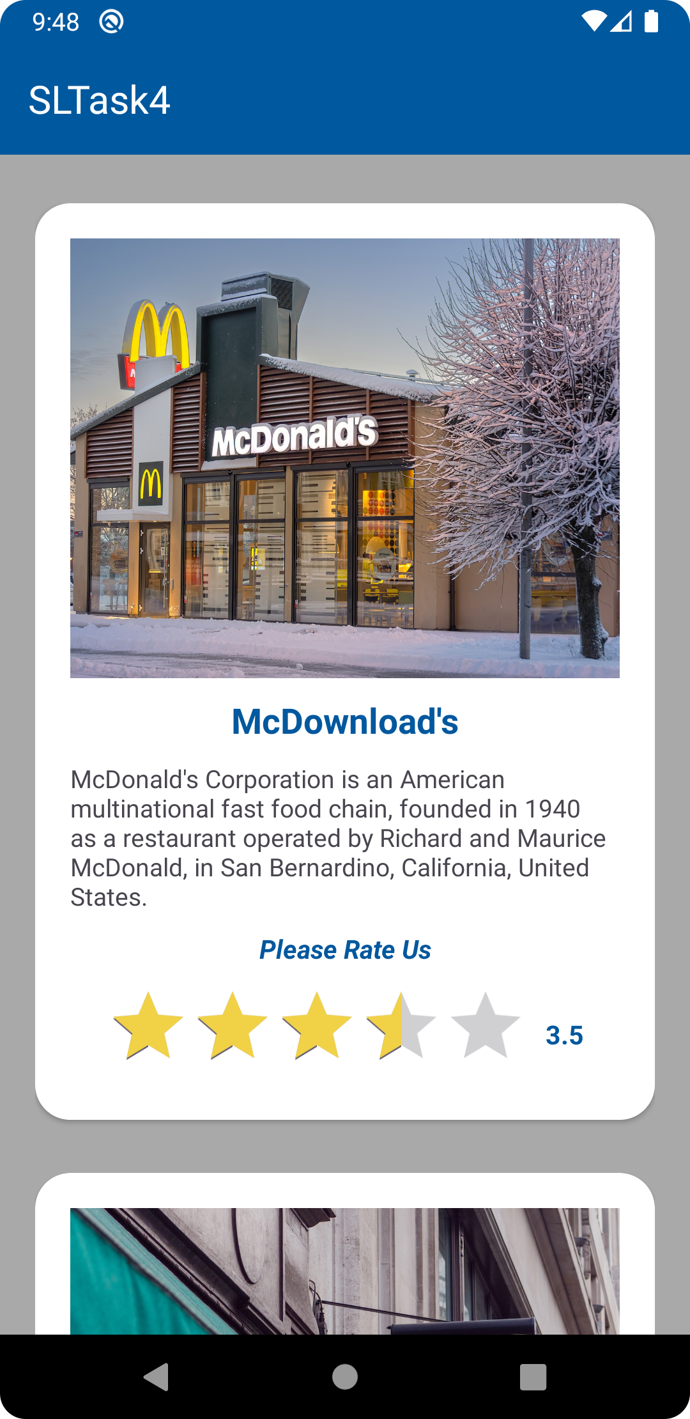

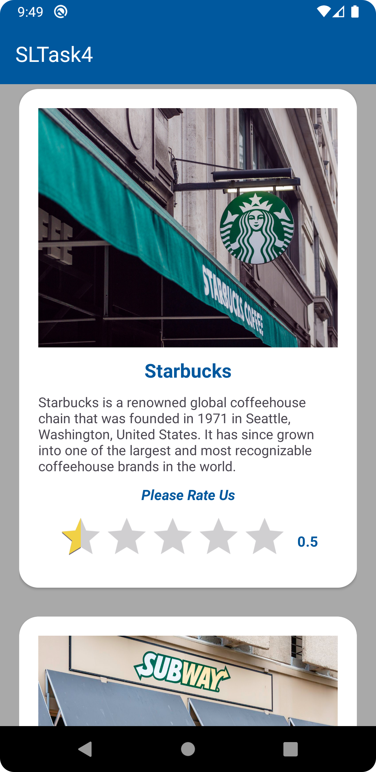 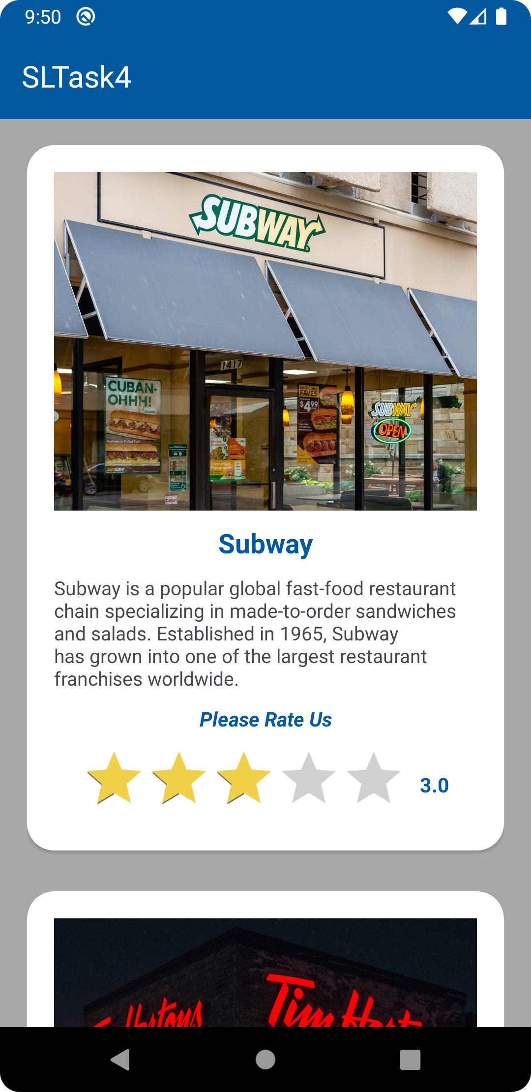

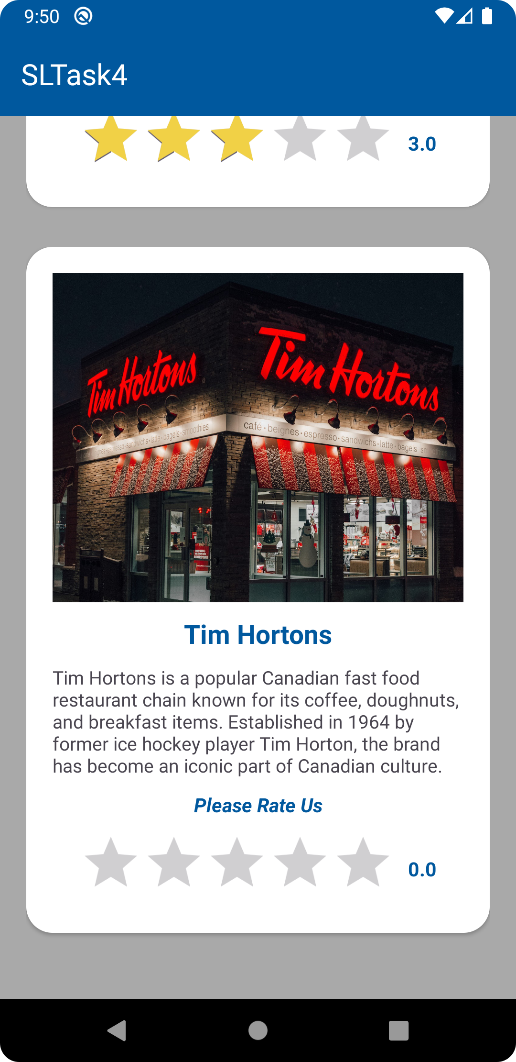

# Source Code

### MainActivity.java

package com.example.siyutask4;  
  
import android.os.Bundle;  
import android.widget.RatingBar;  
  
import androidx.appcompat.app.AppCompatActivity;  
  
import com.example.siyutask4.databinding.ActivityMainBinding;  
  
public class MainActivity extends AppCompatActivity implements RatingBar.OnRatingBarChangeListener {  
  
 ActivityMainBinding binding;  
 RatingBar r1Bar;  
 RatingBar r2Bar;  
 RatingBar r3Bar;  
 RatingBar r4Bar;  
 RatingBar r5Bar;  
  
 @Override  
 protected void onCreate(Bundle savedInstanceState) {  
 super.onCreate(savedInstanceState);  
 binding = ActivityMainBinding.*inflate*(getLayoutInflater());  
 setContentView(binding.getRoot());  
 init();  
 }  
  
 // bind event listeners for the rating bars  
 private void init() {  
 r1Bar = binding.restaurant1.cardViewRatingbar1;  
 r1Bar.setOnRatingBarChangeListener(this);  
  
 r2Bar = binding.restaurant2.cardViewRatingbar2;  
 r2Bar.setOnRatingBarChangeListener(this);  
  
 r3Bar = binding.restaurant3.cardViewRatingbar3;  
 r3Bar.setOnRatingBarChangeListener(this);  
  
 r4Bar = binding.restaurant4.cardViewRatingbar4;  
 r4Bar.setOnRatingBarChangeListener(this);  
  
 r5Bar = binding.restaurant5.cardViewRatingbar5;  
 r5Bar.setOnRatingBarChangeListener(this);  
 }  
  
  
 // set the rating number by retrieving the data of rating bar  
 @Override  
 public void onRatingChanged(RatingBar ratingBar, float rating, boolean fromUser) {  
 if (ratingBar.getId() == r1Bar.getId()) {  
 binding.restaurant1.cardViewRateNumber.setText(String.*valueOf*(rating));  
 } else if (ratingBar.getId() == r2Bar.getId()) {  
 binding.restaurant2.cardViewRateNumber.setText(String.*valueOf*(rating));  
 } else if (ratingBar.getId() == r3Bar.getId()) {  
 binding.restaurant3.cardViewRateNumber.setText(String.*valueOf*(rating));  
 } else if (ratingBar.getId() == r4Bar.getId()) {  
 binding.restaurant4.cardViewRateNumber.setText(String.*valueOf*(rating));  
 } else if (ratingBar.getId() == r5Bar.getId()) {  
 binding.restaurant5.cardViewRateNumber.setText(String.*valueOf*(rating));  
 }  
 }  
}

### activity_main.xml

<?xml version="1.0" encoding="utf-8"?>  
<LinearLayout xmlns:android="http://schemas.android.com/apk/res/android"  
 xmlns:app="http://schemas.android.com/apk/res-auto"  
 xmlns:tools="http://schemas.android.com/tools"  
 android:layout_width="match_parent"  
 android:layout_height="match_parent"  
 android:orientation="vertical"  
 tools:context=".MainActivity">  
  
 <com.google.android.material.appbar.MaterialToolbar  
 android:id="@+id/materialToolbar"  
 android:layout_width="match_parent"  
 android:layout_height="wrap_content"  
 android:background="?attr/colorPrimary"  
 android:minHeight="?attr/actionBarSize"  
 android:theme="?attr/actionBarTheme"  
 app:title="@string/app_title"  
 app:titleTextColor="@color/white" />  
  
 <ScrollView  
 android:layout_width="match_parent"  
 android:layout_height="wrap_content"  
 android:background="@color/gray">  
  
 <LinearLayout  
 android:layout_width="match_parent"  
 android:layout_height="wrap_content"  
 android:orientation="vertical"  
 android:padding="@dimen/OutsideContainerPadding">  
  
 <include  
 android:id="@+id/restaurant1"  
 layout="@layout/restaurant1" />  
  
 <include  
 android:id="@+id/restaurant2"  
 layout="@layout/restaurant2" />  
  
 <include  
 android:id="@+id/restaurant3"  
 layout="@layout/restaurant3" />  
  
 <include  
 android:id="@+id/restaurant4"  
 layout="@layout/restaurant4" />  
  
 <include  
 android:id="@+id/restaurant5"  
 layout="@layout/restaurant5" />  
 </LinearLayout>  
 </ScrollView>  
  
  
</LinearLayout>

### restaurant1.xml

<?xml version="1.0" encoding="utf-8"?>  
<LinearLayout xmlns:android="http://schemas.android.com/apk/res/android"  
 xmlns:app="http://schemas.android.com/apk/res-auto"  
 android:layout_width="match_parent"  
 android:layout_height="match_parent">  
  
 <androidx.cardview.widget.CardView  
 android:id="@+id/card_view"  
 android:layout_width="match_parent"  
 android:layout_height="wrap_content"  
 android:layout_marginBottom="@dimen/CardContainerMargin"  
 app:cardCornerRadius="@dimen/CardContainerCornerRadius">  
  
 <LinearLayout  
 android:layout_width="match_parent"  
 android:layout_height="wrap_content"  
 android:orientation="vertical"  
 android:padding="@dimen/CardContainerPadding">  
  
 <ImageView  
 android:id="@+id/card_view_img"  
 android:layout_width="match_parent"  
 android:layout_height="250dp"  
 android:scaleType="centerCrop"  
 android:src="@drawable/burgerking" />  
  
 <TextView  
 android:id="@+id/card_view_title"  
 style="@style/CardFont"  
 android:layout_width="match_parent"  
 android:layout_height="wrap_content"  
 android:text="@string/restaurant_one_title"  
 android:textSize="@dimen/CardFont.Title" />  
  
 <TextView  
 android:id="@+id/card_view_desc"  
 android:layout_width="wrap_content"  
 android:layout_height="match_parent"  
 android:text="@string/restaurant_one_desc" />  
  
 <TextView  
 android:id="@+id/card_view_rate_message"  
 style="@style/CardFont"  
 android:layout_width="match_parent"  
 android:layout_height="wrap_content"  
 android:text="@string/rate_text"  
 android:textSize="@dimen/CardFont.Rate"  
 android:textStyle="italic|bold" />  
  
 <LinearLayout  
 android:layout_width="match_parent"  
 android:layout_height="wrap_content"  
 android:gravity="center"  
 android:orientation="horizontal">  
  
 <RatingBar  
 android:id="@+id/card_view_ratingbar1"  
 android:layout_width="wrap_content"  
 android:layout_height="wrap_content"  
 android:progressTint="@color/gold" />  
  
 <TextView  
 android:id="@+id/card_view_rate_number"  
 android:layout_width="wrap_content"  
 android:layout_height="wrap_content"  
 android:layout_marginStart="@dimen/CardFont.Rate.NumberPadding"  
 android:text="@string/initial_rate"  
 android:textColor="@color/primary"  
 android:textSize="@dimen/CardFont.Rate.Number"  
 android:textStyle="bold" />  
 </LinearLayout>  
 </LinearLayout>  
 </androidx.cardview.widget.CardView>  
</LinearLayout>

### restaurant2.xml

<?xml version="1.0" encoding="utf-8"?>  
<LinearLayout xmlns:android="http://schemas.android.com/apk/res/android"  
 xmlns:app="http://schemas.android.com/apk/res-auto"  
 android:layout_width="match_parent"  
 android:layout_height="match_parent">  
  
 <androidx.cardview.widget.CardView  
 android:id="@+id/card_view"  
 android:layout_width="match_parent"  
 android:layout_height="wrap_content"  
 android:layout_marginBottom="@dimen/CardContainerMargin"  
 app:cardCornerRadius="@dimen/CardContainerCornerRadius">  
  
 <LinearLayout  
 android:layout_width="match_parent"  
 android:layout_height="wrap_content"  
 android:orientation="vertical"  
 android:padding="@dimen/CardContainerPadding">  
  
 <ImageView  
 android:id="@+id/card_view_img"  
 android:layout_width="match_parent"  
 android:layout_height="250dp"  
 android:scaleType="centerCrop"  
 android:src="@drawable/mcdonalds" />  
  
 <TextView  
 android:id="@+id/card_view_title"  
 style="@style/CardFont"  
 android:layout_width="match_parent"  
 android:layout_height="wrap_content"  
 android:text="@string/restaurant_two_title"  
 android:textSize="@dimen/CardFont.Title" />  
  
 <TextView  
 android:id="@+id/card_view_desc"  
 android:layout_width="wrap_content"  
 android:layout_height="match_parent"  
 android:text="@string/restaurant_two_desc" />  
  
 <TextView  
 android:id="@+id/card_view_rate_message"  
 style="@style/CardFont"  
 android:layout_width="match_parent"  
 android:layout_height="wrap_content"  
 android:text="@string/rate_text"  
 android:textSize="@dimen/CardFont.Rate"  
 android:textStyle="italic|bold" />  
  
 <LinearLayout  
 android:layout_width="match_parent"  
 android:layout_height="wrap_content"  
 android:gravity="center"  
 android:orientation="horizontal">  
  
 <RatingBar  
 android:id="@+id/card_view_ratingbar2"  
 android:layout_width="wrap_content"  
 android:layout_height="wrap_content"  
 android:progressTint="@color/gold" />  
  
 <TextView  
 android:id="@+id/card_view_rate_number"  
 android:layout_width="wrap_content"  
 android:layout_height="wrap_content"  
 android:layout_marginStart="@dimen/CardFont.Rate.NumberPadding"  
 android:text="@string/initial_rate"  
 android:textColor="@color/primary"  
 android:textSize="@dimen/CardFont.Rate.Number"  
 android:textStyle="bold" />  
 </LinearLayout>  
 </LinearLayout>  
 </androidx.cardview.widget.CardView>  
</LinearLayout>

### restaurant3.xml

<?xml version="1.0" encoding="utf-8"?>  
<LinearLayout xmlns:android="http://schemas.android.com/apk/res/android"  
 xmlns:app="http://schemas.android.com/apk/res-auto"  
 android:layout_width="match_parent"  
 android:layout_height="match_parent">  
  
 <androidx.cardview.widget.CardView  
 android:id="@+id/card_view"  
 android:layout_width="match_parent"  
 android:layout_height="wrap_content"  
 android:layout_marginBottom="@dimen/CardContainerMargin"  
 app:cardCornerRadius="@dimen/CardContainerCornerRadius">  
  
 <LinearLayout  
 android:layout_width="match_parent"  
 android:layout_height="wrap_content"  
 android:orientation="vertical"  
 android:padding="@dimen/CardContainerPadding">  
  
 <ImageView  
 android:id="@+id/card_view_img"  
 android:layout_width="match_parent"  
 android:layout_height="250dp"  
 android:scaleType="centerCrop"  
 android:src="@drawable/starbucks" />  
  
 <TextView  
 android:id="@+id/card_view_title"  
 style="@style/CardFont"  
 android:layout_width="match_parent"  
 android:layout_height="wrap_content"  
 android:text="@string/restaurant_three_title"  
 android:textSize="@dimen/CardFont.Title" />  
  
 <TextView  
 android:id="@+id/card_view_desc"  
 android:layout_width="wrap_content"  
 android:layout_height="match_parent"  
 android:text="@string/restaurant_three_desc" />  
  
 <TextView  
 android:id="@+id/card_view_rate_message"  
 style="@style/CardFont"  
 android:layout_width="match_parent"  
 android:layout_height="wrap_content"  
 android:text="@string/rate_text"  
 android:textSize="@dimen/CardFont.Rate"  
 android:textStyle="italic|bold" />  
  
 <LinearLayout  
 android:layout_width="match_parent"  
 android:layout_height="wrap_content"  
 android:gravity="center"  
 android:orientation="horizontal">  
  
 <RatingBar  
 android:id="@+id/card_view_ratingbar3"  
 android:layout_width="wrap_content"  
 android:layout_height="wrap_content"  
 android:progressTint="@color/gold" />  
  
 <TextView  
 android:id="@+id/card_view_rate_number"  
 android:layout_width="wrap_content"  
 android:layout_height="wrap_content"  
 android:layout_marginStart="@dimen/CardFont.Rate.NumberPadding"  
 android:text="@string/initial_rate"  
 android:textColor="@color/primary"  
 android:textSize="@dimen/CardFont.Rate.Number"  
 android:textStyle="bold" />  
 </LinearLayout>  
 </LinearLayout>  
 </androidx.cardview.widget.CardView>  
</LinearLayout>

### restaurant4.xml

<?xml version="1.0" encoding="utf-8"?>  
<LinearLayout xmlns:android="http://schemas.android.com/apk/res/android"  
 xmlns:app="http://schemas.android.com/apk/res-auto"  
 android:layout_width="match_parent"  
 android:layout_height="match_parent">  
  
 <androidx.cardview.widget.CardView  
 android:id="@+id/card_view"  
 android:layout_width="match_parent"  
 android:layout_height="wrap_content"  
 android:layout_marginBottom="@dimen/CardContainerMargin"  
 app:cardCornerRadius="@dimen/CardContainerCornerRadius">  
  
 <LinearLayout  
 android:layout_width="match_parent"  
 android:layout_height="wrap_content"  
 android:orientation="vertical"  
 android:padding="@dimen/CardContainerPadding">  
  
 <ImageView  
 android:id="@+id/card_view_img"  
 android:layout_width="match_parent"  
 android:layout_height="250dp"  
 android:scaleType="centerCrop"  
 android:src="@drawable/subway" />  
  
 <TextView  
 android:id="@+id/card_view_title"  
 style="@style/CardFont"  
 android:layout_width="match_parent"  
 android:layout_height="wrap_content"  
 android:text="@string/restaurant_four_title"  
 android:textSize="@dimen/CardFont.Title" />  
  
 <TextView  
 android:id="@+id/card_view_desc"  
 android:layout_width="wrap_content"  
 android:layout_height="match_parent"  
 android:text="@string/restaurant_four_desc" />  
  
 <TextView  
 android:id="@+id/card_view_rate_message"  
 style="@style/CardFont"  
 android:layout_width="match_parent"  
 android:layout_height="wrap_content"  
 android:text="@string/rate_text"  
 android:textSize="@dimen/CardFont.Rate"  
 android:textStyle="italic|bold" />  
  
 <LinearLayout  
 android:layout_width="match_parent"  
 android:layout_height="wrap_content"  
 android:gravity="center"  
 android:orientation="horizontal">  
  
 <RatingBar  
 android:id="@+id/card_view_ratingbar4"  
 android:layout_width="wrap_content"  
 android:layout_height="wrap_content"  
 android:progressTint="@color/gold" />  
  
 <TextView  
 android:id="@+id/card_view_rate_number"  
 android:layout_width="wrap_content"  
 android:layout_height="wrap_content"  
 android:layout_marginStart="@dimen/CardFont.Rate.NumberPadding"  
 android:text="@string/initial_rate"  
 android:textColor="@color/primary"  
 android:textSize="@dimen/CardFont.Rate.Number"  
 android:textStyle="bold" />  
 </LinearLayout>  
 </LinearLayout>  
 </androidx.cardview.widget.CardView>  
</LinearLayout>

### restaurant5.xml

<?xml version="1.0" encoding="utf-8"?>  
<LinearLayout xmlns:android="http://schemas.android.com/apk/res/android"  
 xmlns:app="http://schemas.android.com/apk/res-auto"  
 android:layout_width="match_parent"  
 android:layout_height="match_parent">  
  
 <androidx.cardview.widget.CardView  
 android:id="@+id/card_view"  
 android:layout_width="match_parent"  
 android:layout_height="wrap_content"  
 android:layout_marginBottom="@dimen/CardContainerMargin"  
 app:cardCornerRadius="@dimen/CardContainerCornerRadius">  
  
 <LinearLayout  
 android:layout_width="match_parent"  
 android:layout_height="wrap_content"  
 android:orientation="vertical"  
 android:padding="@dimen/CardContainerPadding">  
  
 <ImageView  
 android:id="@+id/card_view_img"  
 android:layout_width="match_parent"  
 android:layout_height="250dp"  
 android:scaleType="centerCrop"  
 android:src="@drawable/timhortons" />  
  
 <TextView  
 android:id="@+id/card_view_title"  
 style="@style/CardFont"  
 android:layout_width="match_parent"  
 android:layout_height="wrap_content"  
 android:text="@string/restaurant_five_title"  
 android:textSize="@dimen/CardFont.Title" />  
  
 <TextView  
 android:id="@+id/card_view_desc"  
 android:layout_width="wrap_content"  
 android:layout_height="match_parent"  
 android:text="@string/restaurant_five_desc" />  
  
 <TextView  
 android:id="@+id/card_view_rate_message"  
 style="@style/CardFont"  
 android:layout_width="match_parent"  
 android:layout_height="wrap_content"  
 android:text="@string/rate_text"  
 android:textSize="@dimen/CardFont.Rate"  
 android:textStyle="italic|bold" />  
  
 <LinearLayout  
 android:layout_width="match_parent"  
 android:layout_height="wrap_content"  
 android:gravity="center"  
 android:orientation="horizontal">  
  
 <RatingBar  
 android:id="@+id/card_view_ratingbar5"  
 android:layout_width="wrap_content"  
 android:layout_height="wrap_content"  
 android:progressTint="@color/gold" />  
  
 <TextView  
 android:id="@+id/card_view_rate_number"  
 android:layout_width="wrap_content"  
 android:layout_height="wrap_content"  
 android:layout_marginStart="@dimen/CardFont.Rate.NumberPadding"  
 android:text="@string/initial_rate"  
 android:textColor="@color/primary"  
 android:textSize="@dimen/CardFont.Rate.Number"  
 android:textStyle="bold" />  
 </LinearLayout>  
 </LinearLayout>  
 </androidx.cardview.widget.CardView>  
</LinearLayout>